Merced High Bears 2015-2016 Wrestling Schedule

Day Date Opponent Place Time
Tues. 11/24 Madera South Scrimmage Madera 1:00
Mon. 11/30 Orange/Black ?? Merced 6:00
Sat. 12/5 Turlock Dual Tournament (JV) Turlock 9:00
Sat. 12/12 Curt Mettler Tournament (V) Elk Grove 9:00
Sat. 12/12 Livingston JV Tournament Livingston 9:00
Sat. 12/19 Morningstar Invitational (V) Los Banos 9:00
Sat. 12/19 Pacheco Invitational (JV) Los Banos 9:00
Wed. 1/6 **Atwater** Merced 6:00
F/S 1/8- 1/9 Apple Cider (V) Watsonville 9:00
Tues. 1/12 **Pitman** Merced 6:00
Sat. 1/16 Westside Invitational (V) Firebaugh 9:00
Sat. 1/16 D-Lo Golden Valley (JV) Merced 9:00
Tues. 1/19 **@ Buhach Colony** Atwater 6:00
Sat. 1/23 Hatler Memorial (JV/V) Sonora 9:00
Wed. 1/27 **@ Turlock** Turlock 6:00
Sat. 1/30 Silverback Classic (JV) Elk Grove 9:00
Wed. 2/3 **@ Golden Valley** Merced 6:00
Sat. 2/7 Team Section Championships Lincoln High 9:00
Thur. 2/11? CCC League Championships Turlock 10:00
F/Sat. 2/19-20 D-1 South Divisional Lincoln, Stockton 10:00
F/S 2/26-2/27 Sac-Joaquin Masters Stockton Arena 10:00
F/S 3/4-3/5 CIF State Championships Bakersfield 9:00

BOLD-DENOTES HOME MATHCES
**-DENOTES LEAGUE MATCHES
Head Coach, Clayton Schneider Asst. Coach, David Granados Asst. Coach, Shgun Hamilton-Smith Asst. Coach, Steven Urquizo Asst. Coach, Alfonso Cintora Asst. Coach, Craig Sano Asst. Coach, Emery Gray Asst. Coach, Chris Urquizo
John Olson, Principal AD, Paul Hogue (**Updated 8/3/15**)

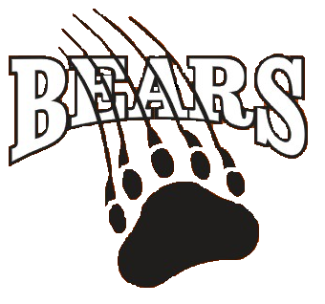

Varsity
12/12 Mettler
12/19 Morningstar
1/8 -1/9 Apple Cider Duals & Individual
1/16 Westside
1/23 Hatler

Junior Varsity
12/5 Turlock Duals
12/12 Livingston
12/19 Pacheco
1/16 D-Lo GV
1/23 Hatler JV
1/30 Silverback

MBWC 15’-16’ Tentative Schedule

11/22 Grace Davis High (SJWA)
11/29 Central Valley (SJWA)
12/6 Atwater (SJWA)
12/13 Livingston (SJWA)
12/20 Los Banos (SJWA)
1/2 -1/3 Selma New Year’s Bash
1/3 Turlock (SJWA)
1/9 - 1/10 Cal Republic
1/17 GV (SJWA) Co-hosting
1/24 Patterson (SJWA)
1/31
2/7 Buhach Colony (SJWA)
2/14 St. Valentines Day Massacre
2/14 Pacheco (SJWA)
2/21 Los Banos-SJWA Championships
2/28
3/19-3/20 USA Folkstyle State
4/7-4/10 Reno World’s?
5/7-5/10 Asic’s Junior National Championships (Las Vegas)?
6/4-6/5 USA Freestyle State

